MUSA presents…

**REU Panel**

Thursday, December 1, 2016

1015 Evans, 6pm

**Math Monday Series**



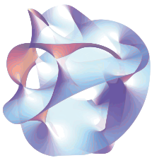

On **Wednesday, November 30 from 2:30-3:30pm in the Simons Auditorium at MSRI**, filmmaker Ekaterina Eremenko will be visiting MSRI to screen her latest film, *Discrete Charm of Geometry*. A team of mathematicians is working together on a big project. Excitement of discovery, hope and disappointment, competition and recognition are shown up close. Scientists united by the idea of discretization, which, in short, means: constructing continuous objects from basic building blocks. Akin to the scientists’ search for the right discretization of continuum, this film itself is composed of fragments – individual characters of different ages, temperaments and scientific approaches – which form a single continuous melody.

**Film screening at MSRI**

Are you looking for something to do in the summer related to **math**? In a few words, REU's are the canonical way for undergraduates to do **mathematical research**, which is a very helpful experience to have when applying to **graduate schools**. You get paid a generous **stipend** and will have a chance to submit your results to math conferences and maybe even **publish** a paper! Our academic officers have put together a group of your peers who’ve been in a variety of REU programs. **Snacks** will be provided!